**PERFORMANCE MONITORING DASHBOARD**

**FILTERS:**

* **DATERANGE(Default Filter)**
* **Connector_id(Custom Filter):**

Display Name :- Connector_Id

SQL Keyword :- Connector_Id

Role :- Analyst

Warehouse :- FIVETRAN_WH

Options Via :- Query

Write Query :- SELECT dISTINCT CONNECTOR_ID FROM FIVETRAN.FIVETRAN_LOG.CONNECTOR;

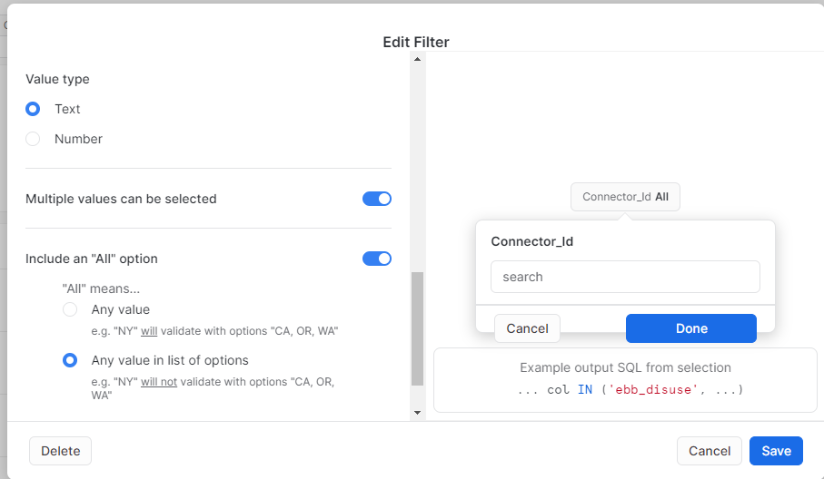

**1.1 Total No of connection**

select connector_name from FIVETRAN.FIVETRAN_LOG.CONNECTOR;

select * from FIVETRAN.FIVETRAN_LOG.CONNECTOR

WHERE _fivetran_synced=:daterange;

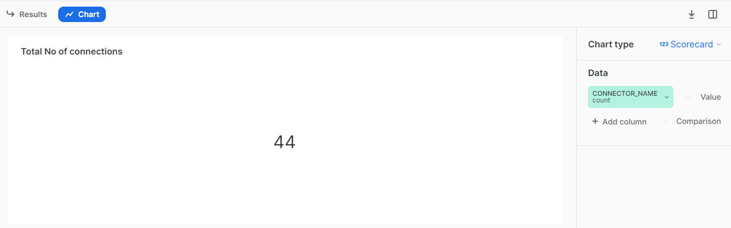

**1.2 Total No of sources**

select count(official_connector_name)

from FIVETRAN.FIVETRAN_LOG.CONNECTOR_TYPE

WHERE _fivetran_synced=:daterange;

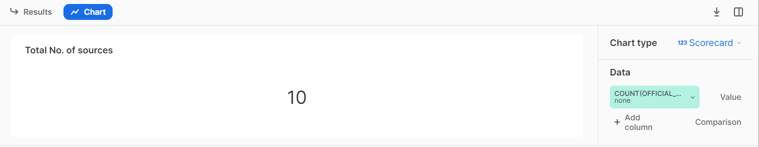

**1.3 Total No of sync**

select count(*) sync_id

from fivetran.fivetran_log.log

where message_event='sync_start'

AND _fivetran_synced=:daterange;

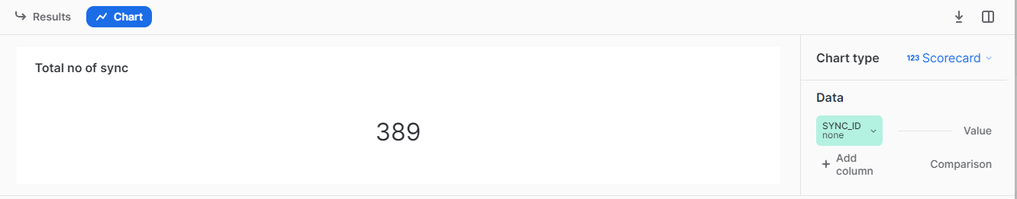

**1.4 Sync success rate%**

SELECT

round( (SUM(CASE

WHEN message_event = 'sync_end' AND parse_json(message_data):status = 'SUCCESSFUL'

THEN 1

ELSE 0

END)/

SUM(CASE

WHEN message_event = 'sync_end'

THEN 1

ELSE 0

END) )*100,2) AS Successrate

FROM

FIVETRAN.FIVETRAN_LOG.LOG

WHERE _fivetran_synced=:daterange;

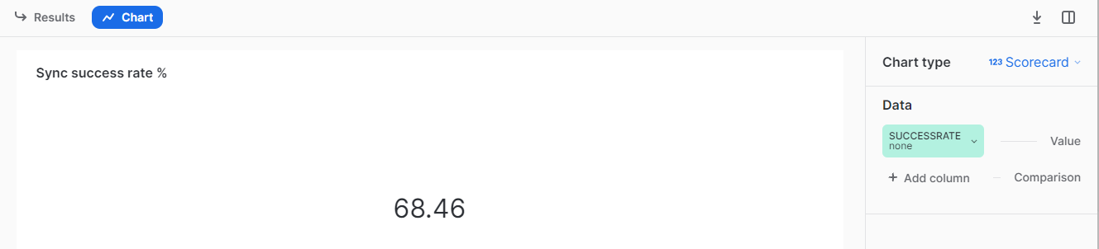

**1.5 Sync Trend**

select connector_id, _fivetran_synced,SYNC_ID

from fivetran.fivetran_log.log

where message_event='sync_start'

AND _fivetran_synced=:daterange ;

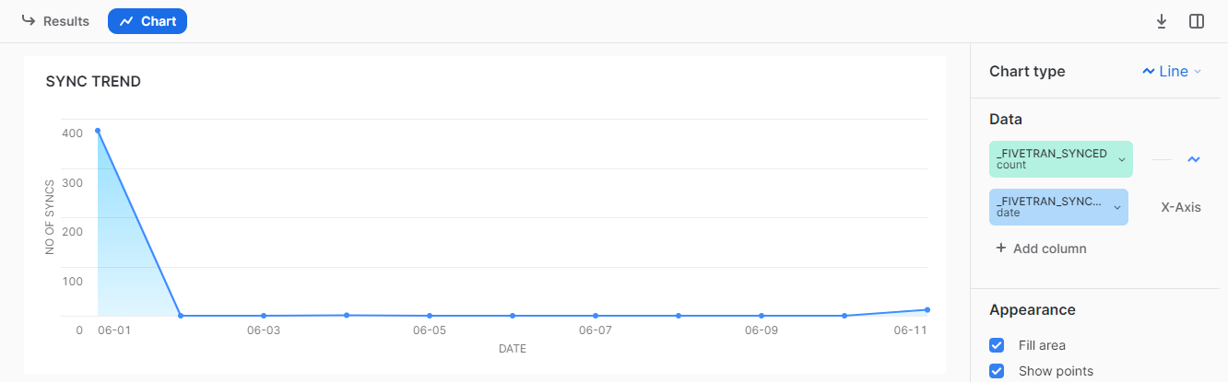

**1.6 No of sync Per connection**

select connector_id, _fivetran_synced,SYNC_ID

from fivetran.fivetran_log.log

where message_event='sync_start'

AND _fivetran_synced=:daterange and CONNECTOR_ID=:Connector_Id;

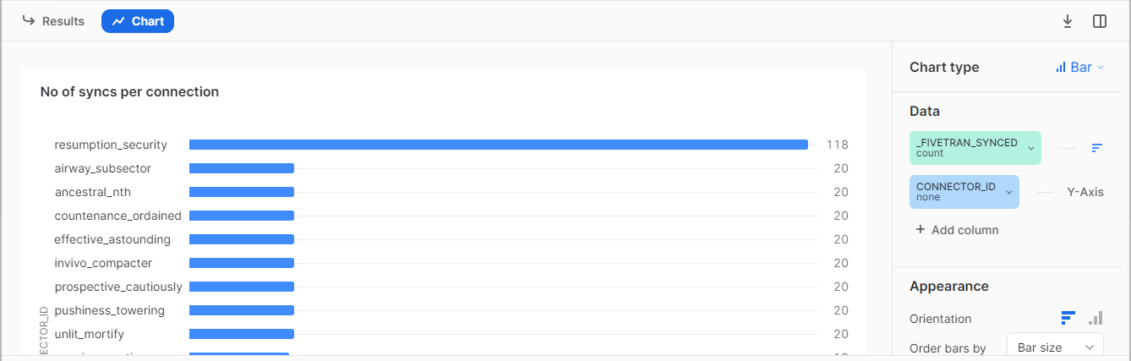

**1.7 Sync execution status**

SELECT

SUM(CASE

WHEN message_event = 'sync_end' AND parse_json(message_data):status = 'SUCCESSFUL'

THEN 1

ELSE 0

END) AS SUCCESSFUL,

SUM(CASE

WHEN message_event = 'sync_end' AND parse_json(message_data):status = 'FAILURE_WITH_TASK'

THEN 1

ELSE 0

END) AS FAILURE_WITH_TASK,

SUM(CASE

WHEN message_event = 'sync_end' AND parse_json(message_data):status = 'RESCHEDULED'

THEN 1

ELSE 0

END) as RESCHEDULED

FROM

FIVETRAN.FIVETRAN_LOG.LOG

WHERE _fivetran_synced=:daterange;

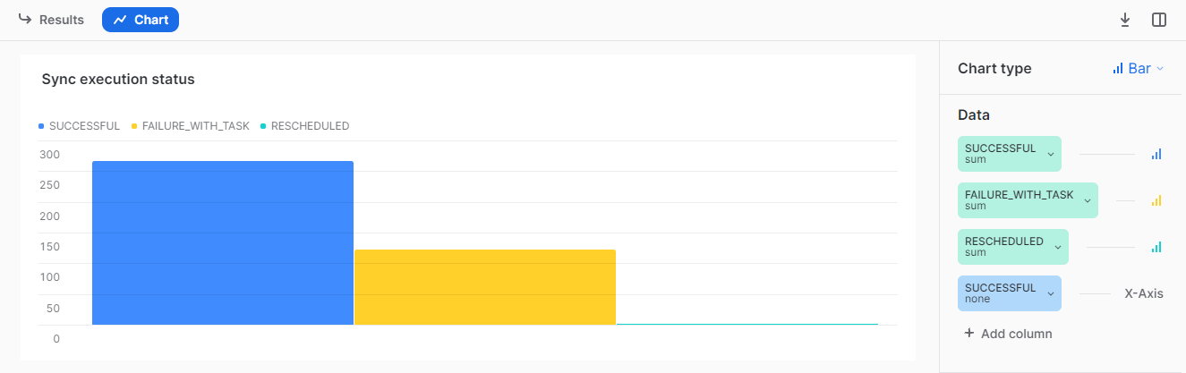

**1.8 Source with no of connection**

SELECT connector_type_id , count(connector_name) as No_of_connections

FROM FIVETRAN.FIVETRAN_LOG.CONNECTOR

WHERE _fivetran_synced=:daterange

GROUP by connector_type_id;

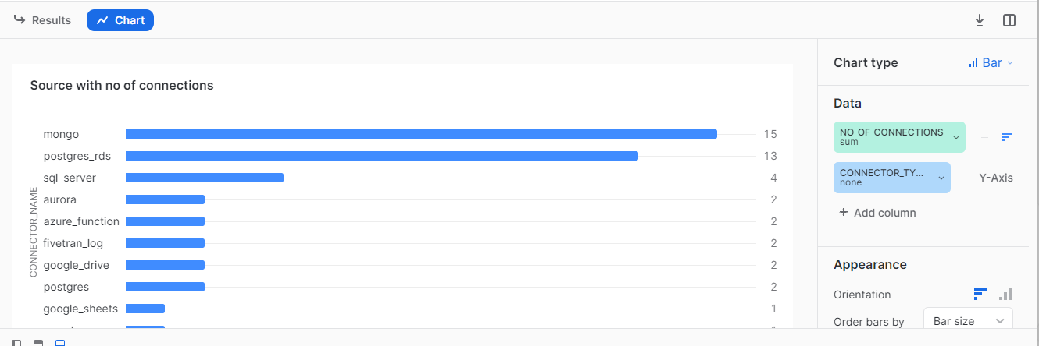

**1.9 Sync frequency of each connection**

Select connector_id,round(sync_frequency/60,1 )

from FIVETRAN.FIVETRAN_LOG.CONNECTOR

WHERE _fivetran_synced=:daterange AND CONNECTOR_ID=:Connector_Id;

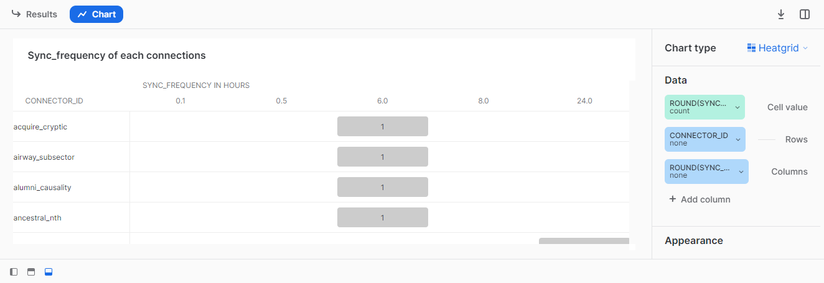

**1.10 Connection Sync Status**

SELECT connector_id,

CASE WHEN paused = 'TRUE' THEN 'PAUSED'

WHEN paused = 'FALSE' THEN 'ACTIVE'

END AS connector_status,

COUNT(*) AS status_count

FROM FIVETRAN.FIVETRAN_LOG.CONNECTOR

WHERE _fivetran_synced=:daterange AND CONNECTOR_ID=:Connector_Id

GROUP BY connector_id, connector_status;

SELECT connector_id,paused

FROM FIVETRAN.FIVETRAN_LOG.CONNECTOR;

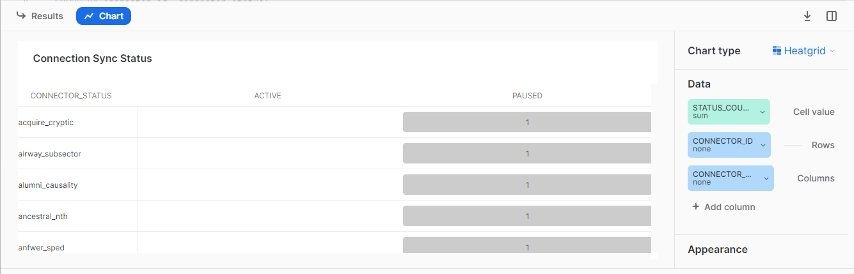

**1.11 Sync duration of each connection**

SELECT connector_id,

MAX(CASE WHEN message_event = 'sync_start' THEN time_stamp END) AS latest_sync_start,

MAX(CASE WHEN message_event = 'sync_end' THEN time_stamp END) AS latest_sync_end,

TIMESTAMPDIFF(SECOND,

MAX(CASE WHEN message_event = 'sync_start' THEN time_stamp END),

MAX(CASE WHEN message_event = 'sync_end' THEN time_stamp END)

) AS time_difference_in_seconds

FROM

FIVETRAN.FIVETRAN_LOG.LOG

WHERE _fivetran_synced=:daterange AND CONNECTOR_ID=:Connector_Id

group by connector_id;

